

________________________________________________________
Artificial Intelligence (Lab)
Lab Report

Submitted By:
Fiza Mushtaq
SU92-BSSEM-S25-016
BSSEM-4A

Submitted To:
SIR Rasikh Ali

Task 01:
- AI History Timeline

- Background of AI Development:
When we talk about AI nowadays we often picture chatbots, robots or computers that can answer our questions.. Ai has not always been this advanced. In the past researchers tried to get computers to solve problems and follow instructions in a way that seemed smart. They faced obstacles because the technology available, at that time was limited. People sometimes expected more from AI than what researchers could provide. As a result funding and interest began to drop. Those periods were known as AI winters. Over time research moved forward and with computers and more data new chances appeared. AI gradually shifted from rules to handling more complex tasks
- Important Milestones in AI History:
Year/Period | Milestone | Explanation | Source
1950 |  | Turing raised the question of whether machines could think and communicate in ways similar to humans. | Turing's Paper (1950)
  Alan Turing
1958 |  | Rosenblatt introduced an early neural network that could learn to identify simple patterns. | Rosenblatt's Paper (1958)
  Perceptron
1966-1972 | Shakey the Robot | Shakey was an early robot that could use information about its surroundings to plan actions and move. | SRI International
1980s-1990s | Expert Systems and AI Slowdown | Expert systems used rules to solve specific problems, but their limitations and costs contributed to another slowdown in AI research. | Encyclopaedia Britannica
2012 | Deep Learning | Alex Net showed that neural networks could improve image recognition by learning from large datasets with powerful computing hardware | Alex Net Research

- References:
- Turing, A. M. (1950): Computing Machinery and Intelligence. Mind, 59(236), 433–460. https://doi.org/10.1093/mind/LIX.236.433
- Rosenblatt, F. (1958): The Perceptron: A Probabilistic Model for Information Storage and Organization in the Brain. Psychological Review, 65(6), 386–408. https://doi.org/10.1037/h0042519
- SRI International: Shakey the Robot. https://www.sri.com/hoi/shakey-the-robot/
- Encyclopaedia Britannica: Artificial Intelligence. https://www.britannica.com/technology/artificial-intelligence
- Krizhevsky, A., Sutskever, I., & Hinton, G. E. (2012): ImageNet Classification with Deep Convolutional Neural Networks. https://arxiv.org/abs/1207.0580
- Conclusion:
The history of AI shows that its development took place over many years rather than happening all at once. Early researchers explored machine intelligence and rule-based problem-solving, while later work introduced neural networks and more advanced systems. AI winters also show that progress was not always easy. Improvements in computing power and access to data helped researchers achieve better results, and modern AI tools have made this technology more visible in everyday life.

Task 02:
- Rule Based Scholarship Agent
- Problem Statement:
A university needs a program to check scholarship applications. The program checks the student's marks and documents to see if the given rules are followed. In this task, I added two more conditions to the original example. The program also shows a reason when a student does not meet a condition
- Objective:
In this task, I modified the scholarship example by adding two new conditions. The program checks a student's information and gives a result based on the rules. It also shows the reason if a student does not meet any condition
- Conditions Used:
I used four conditions in this program:
- The student must have at least 70 marks
- All required documents must be complete
- The student's semester GPA must be at least 2.5
- The student's attendance must be at least 75%
The marks and document conditions were kept from the original example. GPA and attendance were added as two new conditions. The GPA and attendance limits are synthetic lab assumptions chosen for this task, not official university scholarship rules
- Program Working:
I wrote the program in Python using a function named check_student(). It checks each condition one by one. If a student fails any condition, the program saves the reason in a list. If all conditions are satisfied, it displays "Review". Otherwise, it displays "Hold" and explains the problem
- Testing:
I tested the program with four test cases. Each case checks a different situation
- All Conditions Passed: All four conditions are satisfied, so the result should be Review.
- GPA Condition Failed: The GPA is below 2.5, so the result should be Hold.
- Attendance Condition Failed: The attendance is below 75%, so the result should be Hold.
- Marks Threshold Boundary: The student has exactly 70 marks. This checks whether the program accepts the minimum marks when the other conditions are also met
- Test Case Result:
Test Case | Input | Expected Result | Actual Result | Reason for Testing
All conditions pass | Marks: 85, Documents: Complete, GPA: 3.2, Attendance: 90% | Review | Review | To check whether all conditions are satisfied
GPA condition failed | Marks: 85, Documents: Complete, GPA: 2.0, Attendance: 90% |  |  | To check the GPA rule
  Hold
  Hold
Attendance condition failed | Marks: 85, Documents: Complete, GPA: 3.0, Attendance: 60%
  Hold
  Hold
  To check the attendance rule
Marks threshold boundry | Marks: 70, Documents: Complete, GPA: 2.5, Attendance: 75% | Review | Review | To check the minimum marks

Program Output:
I ran the program to check all four test cases. The output shows the input, expected result, actual result, reason, and whether each test passed. This helped me check if the program was giving the correct results
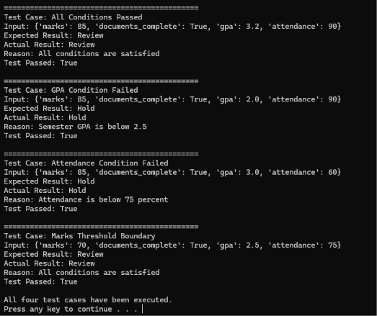

- Results Discussion:
The first test case passed because all conditions were satisfied. In the second case, the GPA was below 2.5, so the program returned Hold. In the third case, attendance was below 75%, so the result was also Hold. In the last case, the student had exactly 70 marks. The program accepted this score because the minimum marks condition is 70 or above. The other conditions were also satisfied, so the result was Review
- Limitations:
This program uses fixed rules and sample values. It does not use real university data. The result depends on the information entered and the conditions written in the code. A real university would need to use its official scholarship policy

- Conclusion:
In this task, I learned how a rule-based program checks information using different conditions. I kept the original marks and document rules and added GPA and attendance. By testing four cases, I checked how the program handles different situations. I also learned how showing a reason helps explain the result
Task 3:
- Comparing Two Results
- Objective:
In this task, I have considered the situation when the example and the program produce different results for the same student
- Working of the Program:
For the test case, I have taken the following student record: 85% marks, 3.2 GPA, complete documents, and 60% attendance. As per the example response, the student’s application should be reviewed since the marks and GPA are excellent. On the other hand, the program will evaluate other factors before taking the final decision
- Test Case:
For this test, I used the following student details:
Student Detail | Value
Marks | 85
Documents | Complete
GPA | 3.2
Attendance | 60%

The example response suggested Review, but the program returned Hold because the student's attendance was below 75%
- Result:
Based on the test case, I have got example response ‘Review’ while the program suggests ‘Hold’ due to low attendance (below 75%). Even though the GPA and Marks are excellent, the student has not met the attendance criteria

- Program Output:
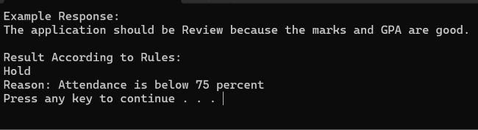
- Comparison of Results:
Through this example, it has been noticed that selective information may mislead the final outcome. In this instance, the example response ignored the attendance and suggested ‘Review.’ On the other hand, the program considers all the parameters before suggesting ‘Hold.’
A conversational test is done to observe how the system responds to the conversation. However, the correct response does not necessarily imply that the system has correctly understood all the information or performed the required task. For instance, the example response fails to recognize the low attendance and recommends a review.
Another test that I would like to perform is to consider other student records for testing the program. For instance, we may take an instance of an incomplete document or a student who met all the conditions. Through such a test, we may verify if the rules are correctly applied or not
- Conclusion:
In the given task, the example response and program have provided two different results for the same student. Since the program suggested ‘Hold,’ I have come to know about the necessity of fulfilling all the criteria
- Reference:
Turing, A. M. (1950). Computing Machinery and Intelligence. Mind, 59(236), 433–460. Web

